Web App Documentation

# EpiStroma WebApp

This application is used to mine the epi-stroma interaction networks. Below is a tutorial of the web application.

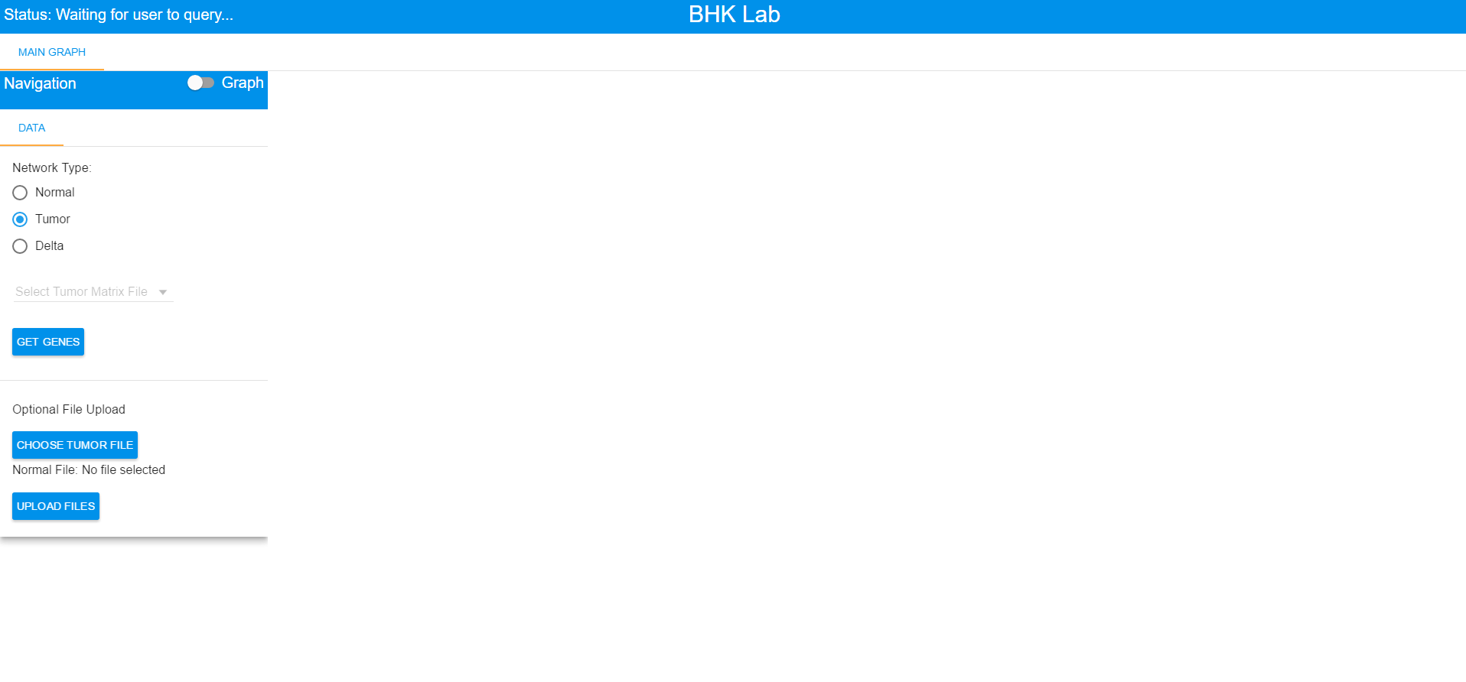

## Getting Started

### Choosing a File

Before any analysis of the network can be done, a network type and associated file(s) must be chosen from Data sub-tab within the Main Graph tab.

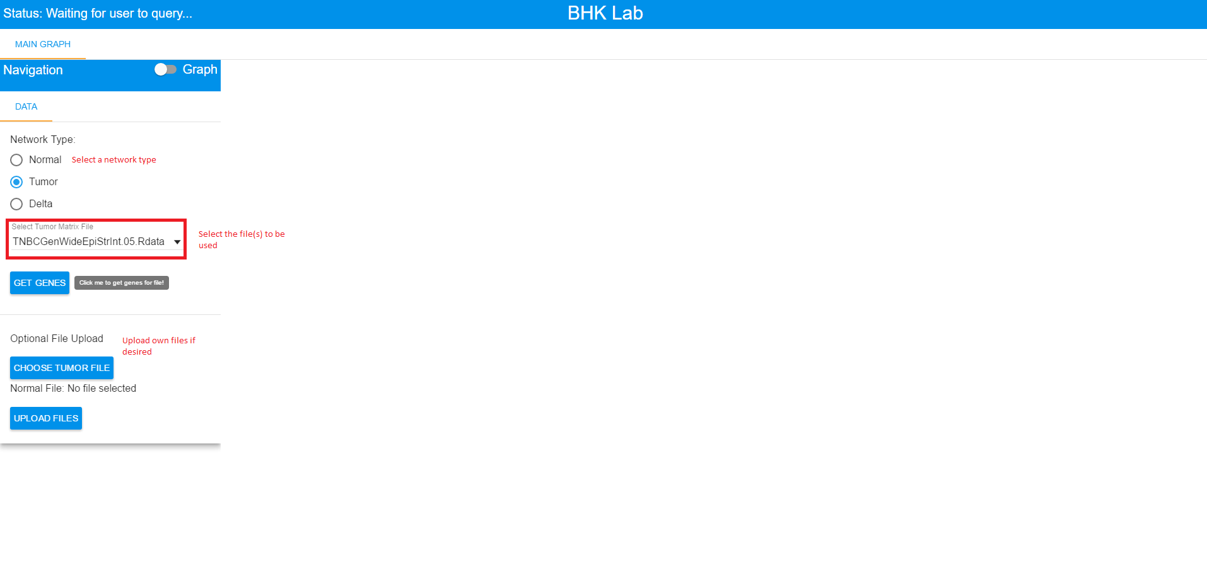

Once a the network type and file(s) are selected, the Get Genes button needs to be pressed in order to enable the other tabs and load the list of genes associated with the specified file(s).

## General Information

### Edge Color and Thickness

The color and thickness that an edge has, gives it semantic meaning.

Grey to black edges represent positive interactions.

Light orange to orange edges represent negative interactions.

The darkness darkness and thickness of an edge represents its relative magnitude to other interactions. For example, say that a graph has only 4 edges in it with the following correlations: -0.8, -0.6, 0.5, 0.65.

The -0.8 edge will be dark orange and will be thick whereas the -0.6 interaction will be light orange and will be thin.

The 0.65 edge will be dark black and will be thick whereas the 0.5 interaction will be light grey and will be thin.

### Interacting With Genes

Clicking on a gene in the graph will highlight only the interactions involving that gene. It will also give a small popup showing the gene name as well as a link to the gene card for that gene.

### Changing Layouts

Within each graphing tab, there exists a sub-tab in the navigation side-box called "Styling". To change the layout of a given graph, go to the "Styling" sub-tab and choose a different layout from the drop-down. The graph will automatically refresh with the newly chosen layout.

There is also a "Resize" button under the styling tab. This button resets the zoom level in case one zooms in too much or too far away and has lost the graph.

## Querying Data

### Main Graph Tab

#### Getting Data

From the Query sub-tab, one can find out information about the first and second neighbours of a group of selected genes. To select a gene, click on the "Choose Genes" box and start typing in the name of a gene. The box will filter down results based on what you've typed so far. You will notice that all gene names have a -E or -S appended to them followed by a number. The -E indicates epi, the -S indicates stroma, and the number indicates the number of first neighbours for that gene.

Let's select CD8A in the stroma, GZMB in the stroma, and CXCL13 in the epi.

As you begin typing CD8A, you will notice that the dropdown list has fewer and fewer results. To choose CD8A-S, simply click on it.

Here is what the app looks like **before** sending the request to the server:

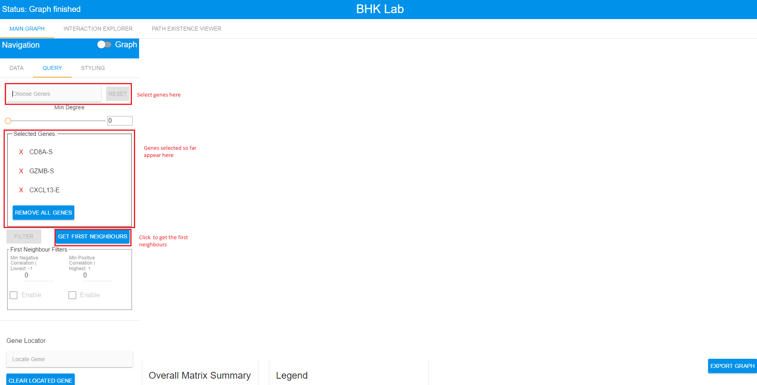

After you have added all genes of interest, click the "Get First Neighbours" button in order to get a graph from the server.

Here is what it looks like **after** the request has been processed:

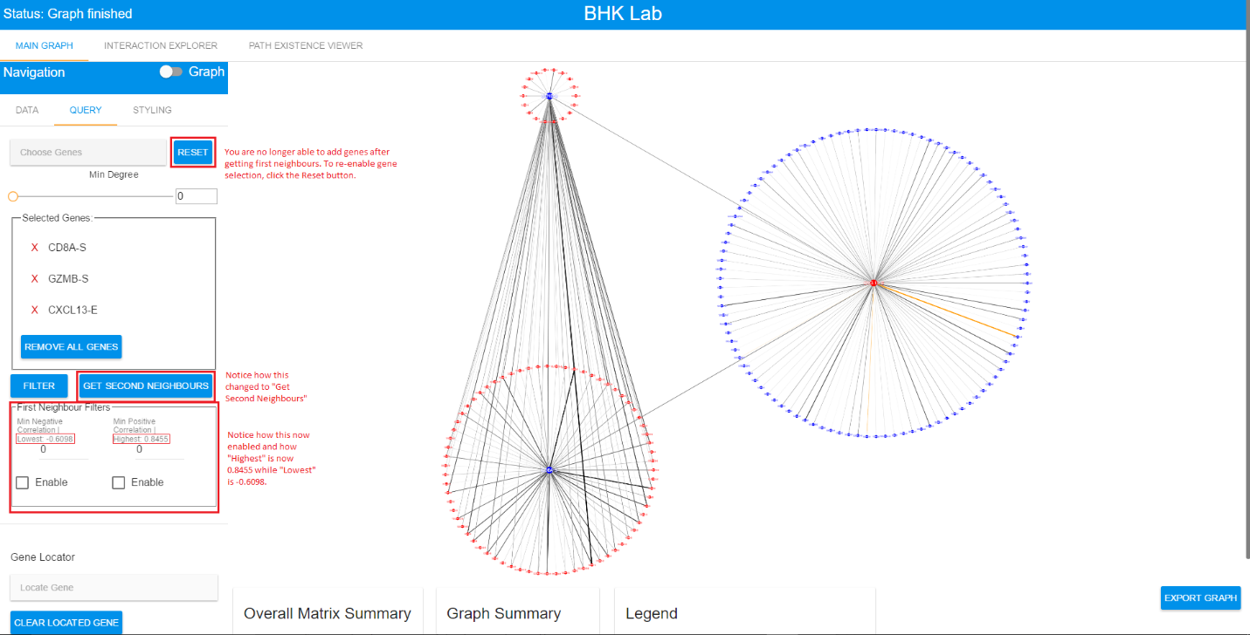

#### Filtering Data

After obtaining the first neighbours, they can be filtered so that only interactions of a specified strength are seen. There are 2 input boxes available for filtering first neighbours interactions.

1. The box labeled "Min Negative Correlation | -1" is used to control only the negative interactions. If one types -0.5 in the box, and selects enable, then only negative interactions of <= -0.5 will be shown. The number after the "|" indicates the lowest interaction in the entire graph. Entering a number lower than this or entering a positive number are both prohibited.

2. The box labeled "Min Positive Correlation | 0.8455" is used to control only the positive interactions. If one types 0.7 in the box, and selects enable, then only positive interactions of >= 0.7 will be shown. The number after the "|" indicates the highest interaction in the entire graph. Entering a number higher than this or entering a negative number are both prohibited.

If one enables both filters, then all interactions <= -0.5 and >= 0.7 will be returned. To get the filtered results, simply click the "Filter" button.

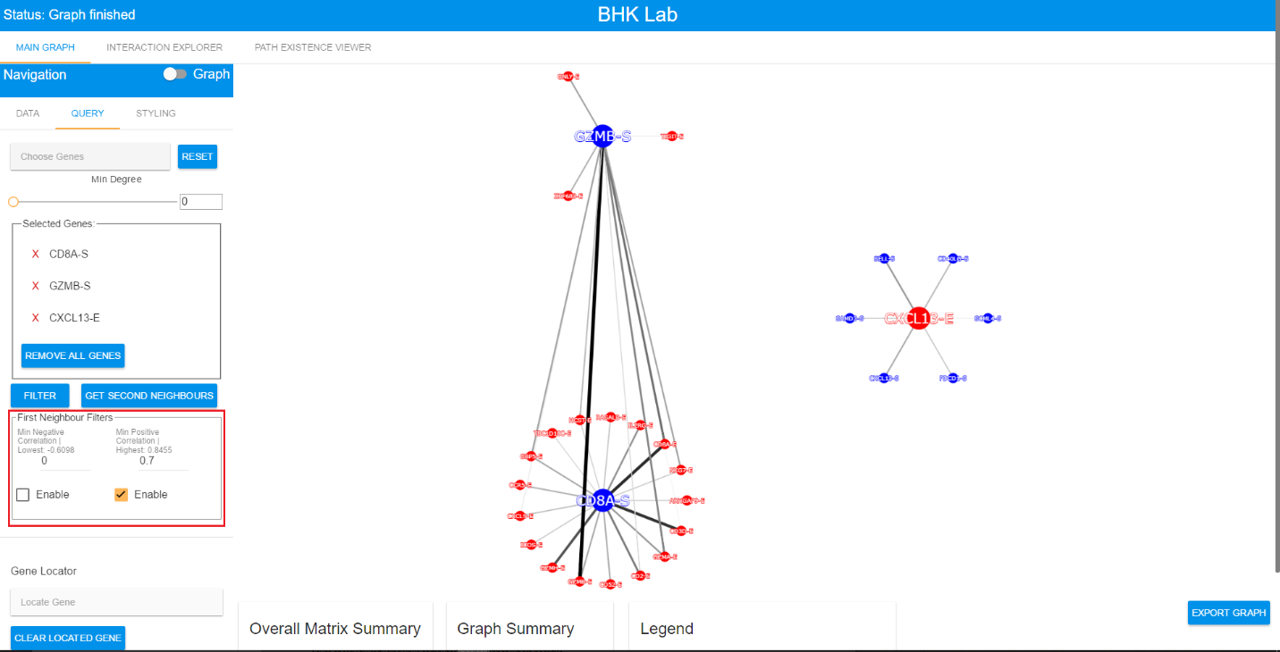

As you can see, the graph was filtered to only obtain positive interactions >= 0.7. This reduced the number of interactions by quite a bit as can be seen in comparison with the previous unfiltered example.

If one doesn't want to filter, then the checkboxes should remain unchecked.

The next step is to get the second neighbours by clicking the "Get Second Neighbours" button.

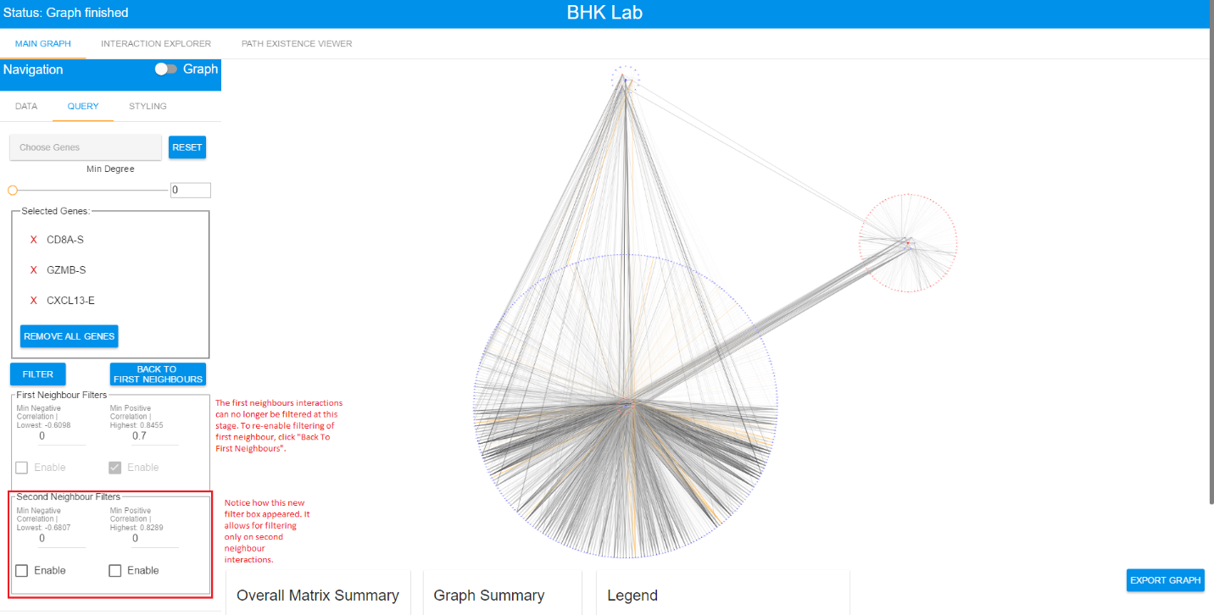

=== Removing Genes of Interest ===

To remove a single gene of interest, click the "Reset Gene Selection" button if it is enabled, then click on a gene underneath "Selected Genes" and click "Remove Gene".

If the "Reset Gene Selection" button is not enabled, then click on a gene underneath "Selected Genes" and click "Remove Gene". The example below shows the process:

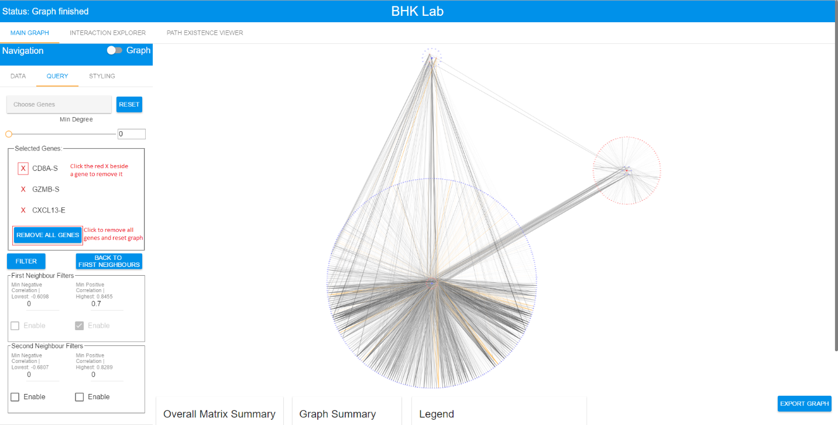

The graph will not be reset when a single gene is removed. The graph only gets reset when all genes are removed.

#### Matrix and Graph Statistics

There are a total of 4 cards at the bottom of the graph, 3 of which are visible by default and the fourth can be seen when an edge is clicked.

**Overall Matrix Summary**: Shows statistics about the overall selected correlation matrix.

**Graph Summary**: Shows statistics about the graph that is currently being displayed.

**Edge Inspector**: Shows information about a selected edge. Appears only when an edge is clicked.

**Legend:** Shows information about the styling in the graph and the meaning of it.

#### Table View

In addition to the graph, the interactions and self-loops can also be seen in a table view which is more convenient for doing analysis with. To go to the table view, click on the switch shown in the below example:

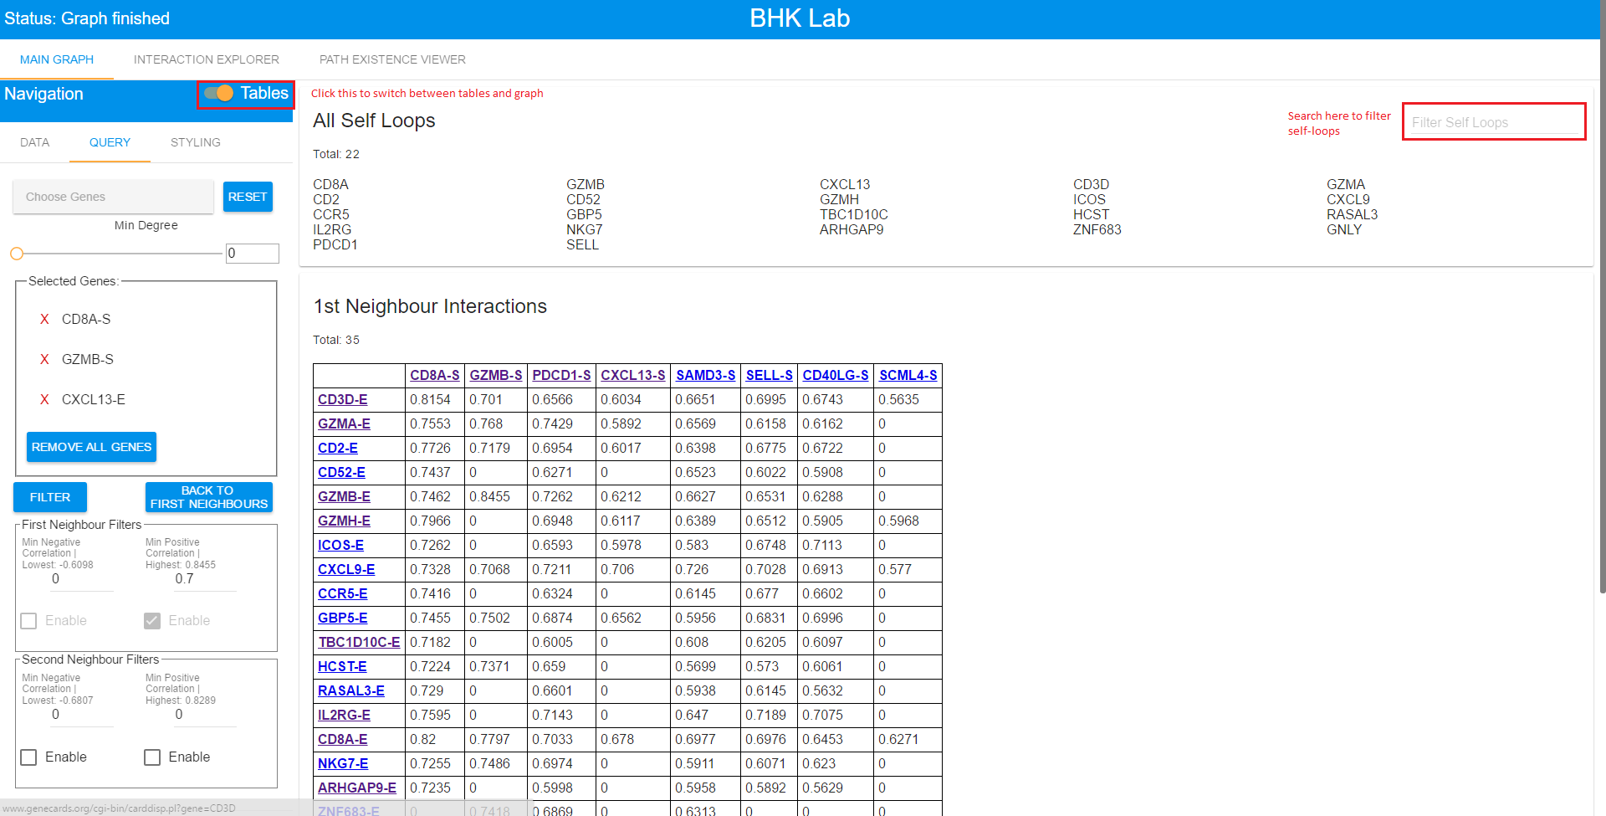

It is also possible to download the results in CSV format by clicking the "Download Interactions" button as shown below:

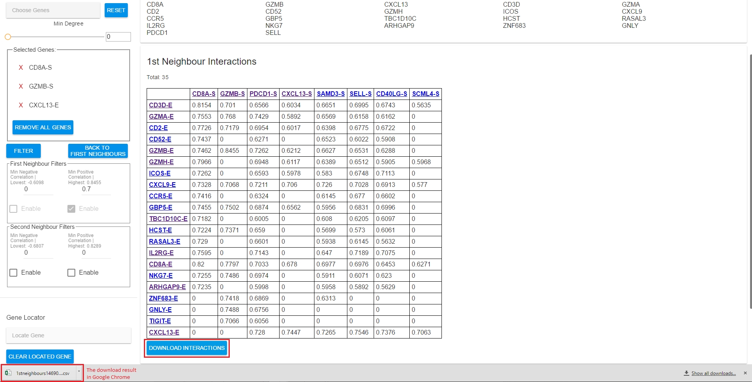

### Interaction Explorer Tab

#### Getting Data

This tab is used for a more targeted approach to exploring the network. First, a user must choose a single gene of interest and then click the "Get Data" button.

{{ :projects:epistromaweb:interaction_explorer_signle_gene.png?850 |}}

Once the graph is loaded, the genes available for selection are simply the neighbours of the selected gene. In this case, the available genes are: STAT1-S, WARS-S, TAP1-S, and LAG3-S.

Suppose that STAT1-S is selected and "Get Data" is then clicked. Here is the resulting graph:

{{ :projects:epistromaweb:interaction_explorer_2_levels.png?850 |}}

This process can be repeated over and over again to go beyond the 2nd neighbour level available in the main graph.

=== Removing Genes of Interest ===

If removing only a single gene, one can only remove the most recently added gene (the gene at the bottom of the Selected Path list). This will refresh the graph to the previous state.

Removing all genes only requires clicking the "Remove All" button. This will clear the graph and all data in the tab.

===== Test Cases =====

==== Main Graph ====

==== Interaction Explorer ====

==== Path Existence ====

===== Timeline =====

==== July 11-15 ====

* Finish implementing multiple file uploads for the delta matrix

* Add the ability to delete a file

* Bulletproof server so that it can’t be crashed by bad requests

* Add more validation to R scripts and send errors in the case that bad information such as a missing gene or incorrect filename are supplied

* Create test cases for the app

* Cleanup code and remove unnecessary files

* Add documentation to the R Code

==== July 18-22 ====

* Add documentation to client-side code

* Add documentation to server-side code

* Separate data from layouts

* Might have to move layout and stying options to client side

* Can instead keep track of which tab request came from (query, layout),

* Create a tab for the communities